HOTEL BOOKING CANCELLATION ANALYSIS
Week 3 – Statistical Analysis, Relationship Analysis & Data Preparation
Dataset: Hotel Booking Demand | Records analysed: 87,396 | Variables: 34

1. Week 3 Objective
The third stage of the project focuses on moving beyond descriptive exploration and testing whether important booking characteristics are associated with cancellation. The analysis compares cancelled and non-cancelled reservations, examines cancellation patterns across customer and booking categories, measures linear relationships using correlation, and prepares a reproducible training and testing split for the predictive model developed in Week 4.

2. Overall Cancellation Profile
The cleaned dataset contains 87,396 booking records. The overall cancellation rate calculated in R was 27.48982%. The class distribution was 63,371 non-cancelled bookings (72.51018%) and 24,025 cancelled bookings (27.48982%).
Booking Status | Count | Percentage
Not Cancelled | 63,371 | 72.51018%
Cancelled | 24,025 | 27.48982%
Total | 87,396 | 100%

3. Cancellation Rate by Booking Characteristics
Cancellation rates were calculated as the mean of the binary is_canceled variable within each category and then converted to percentages. This provides a direct way to compare cancellation behaviour between groups.

Market Segment
The market-segment analysis shows noticeable differences in cancellation behaviour. Online TA has a cancellation rate of approximately 35.35%, while Groups is about 27.01%. Aviation, Complementary, Corporate, Direct and Offline TA/TO have lower rates. The Undefined category reaches 100%, but this result should be interpreted cautiously because it may represent a very small or unusual group rather than a general pattern.
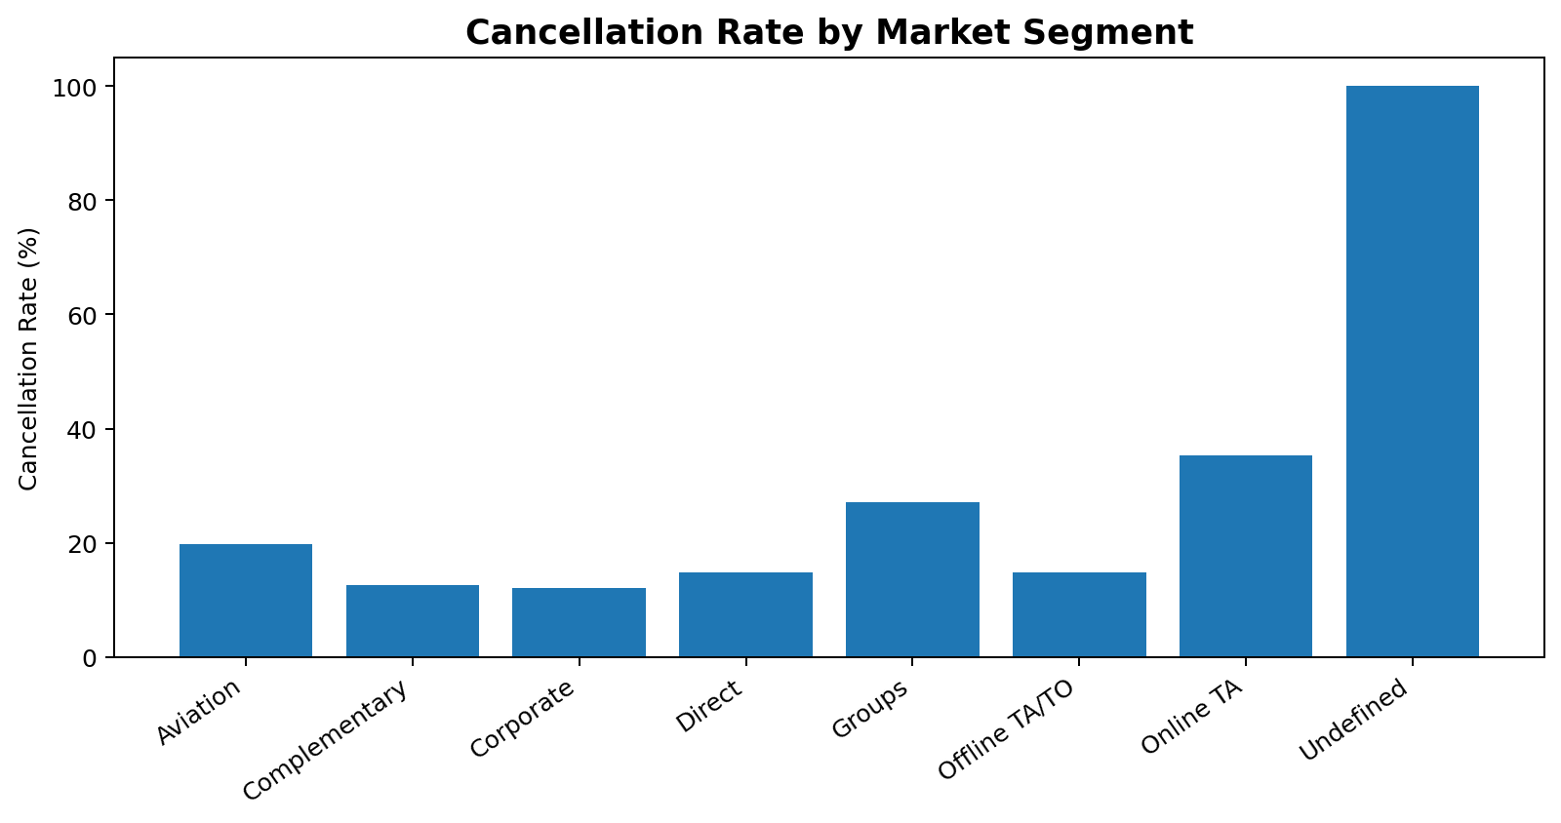

Customer Type
Transient customers have the highest cancellation rate among the main customer groups at approximately 30.11%. Contract customers are around 16.31%, Transient-Party around 15.24%, and Group customers around 9.93%. The result suggests that customer relationship type can be useful when modelling cancellation risk.
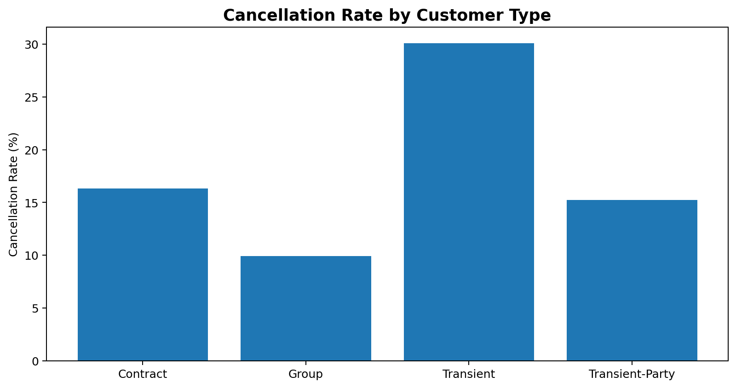

Deposit Type
Deposit type shows one of the strongest differences in the exploratory analysis. Bookings marked as Non Refund have a cancellation rate of approximately 94.70%, compared with about 26.68% for No Deposit and 24.30% for Refundable bookings. Because the Non Refund category is unusually high, it is an important variable for the predictive model and should also be checked for business/data-quality interpretation.
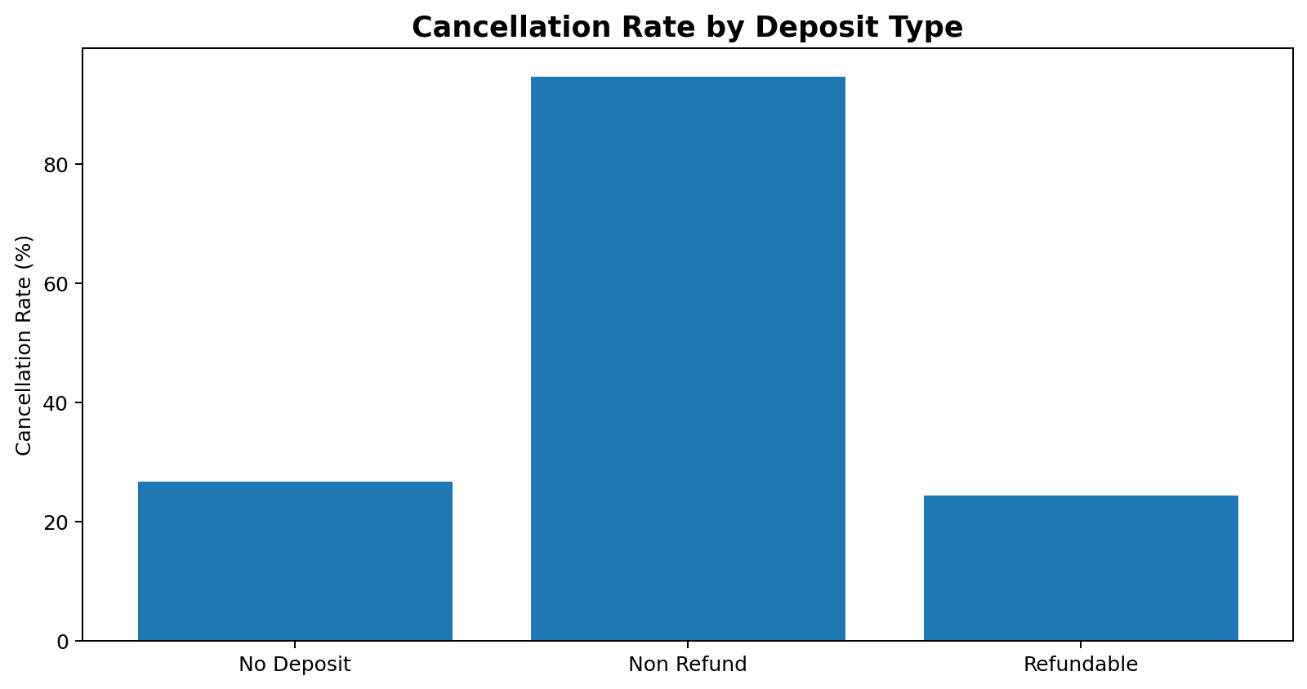

4. Hypothesis Testing
Two Welch two-sample t-tests were performed to determine whether cancelled and non-cancelled bookings differ significantly in average lead time and average daily rate. Welch's test was selected because it does not require the two groups to have equal variances.

Lead Time
Cancelled bookings had an average lead time of 105.719 days, whereas non-cancelled bookings had an average of 70.100 days. The test returned t = 52.719, df = 39,223, with p < 2.2 × 10⁻¹⁶. The 95% confidence interval for the mean difference was 34.295 to 36.944 days. Therefore, the null hypothesis of equal means is rejected. In this dataset, cancelled reservations tend to be made substantially earlier.
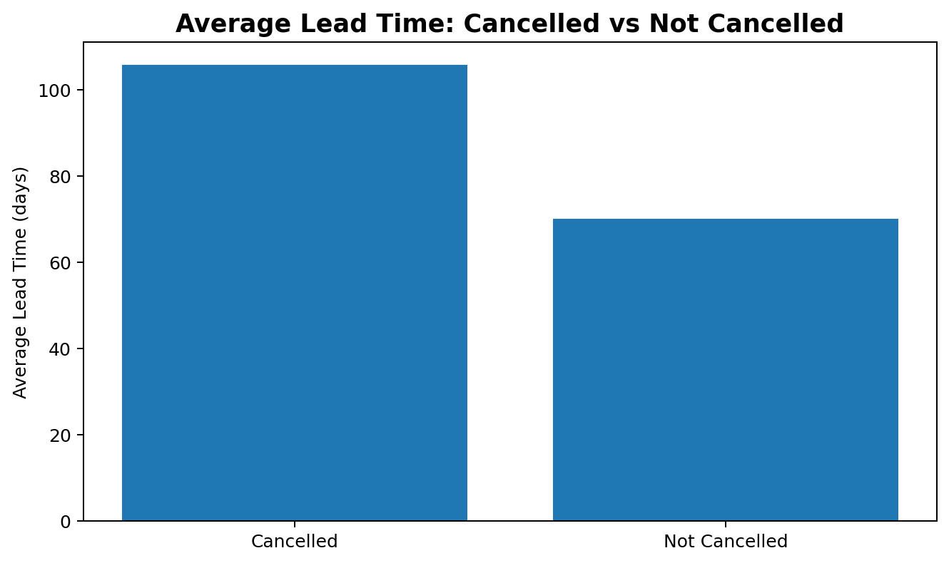

Average Daily Rate (ADR)
The average ADR for cancelled bookings was 117.773, compared with 102.002 for non-cancelled bookings. Welch's t-test produced t = 35.05, df = 37,149, with p < 2.2 × 10⁻¹⁶. The 95% confidence interval for the mean difference was 14.889 to 16.652. This indicates a statistically significant difference in average ADR between the two groups.
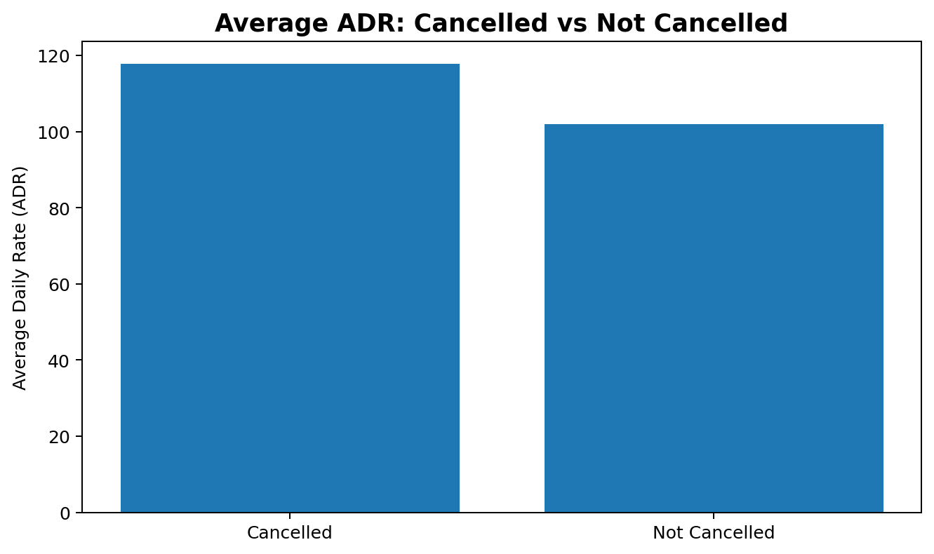

5. Correlation Analysis
Pearson correlations were calculated for selected numerical variables. The correlation with is_canceled was then inspected to identify variables that may have a linear relationship with cancellation. Correlation does not establish causation; it is used here as an exploratory screening technique.
Variable | Correlation with Cancellation
Lead Time | 0.18481
ADR | 0.12799
Booking Changes | -0.09364
Total Special Requests | -0.12055
Stays – Weekend Nights | 0.06019
Stays – Week Nights | 0.08293
Adults | 0.08182
Children | 0.06737
Previous Cancellations | 0.05147
Lead time has the strongest positive correlation with cancellation among the selected variables (r ≈ 0.185), followed by ADR (r ≈ 0.128). Total special requests show a negative correlation (r ≈ -0.121), suggesting that bookings with more special requests tend to be less likely to be cancelled in this dataset. These relationships are modest, so cancellation cannot be explained by any single numerical variable.
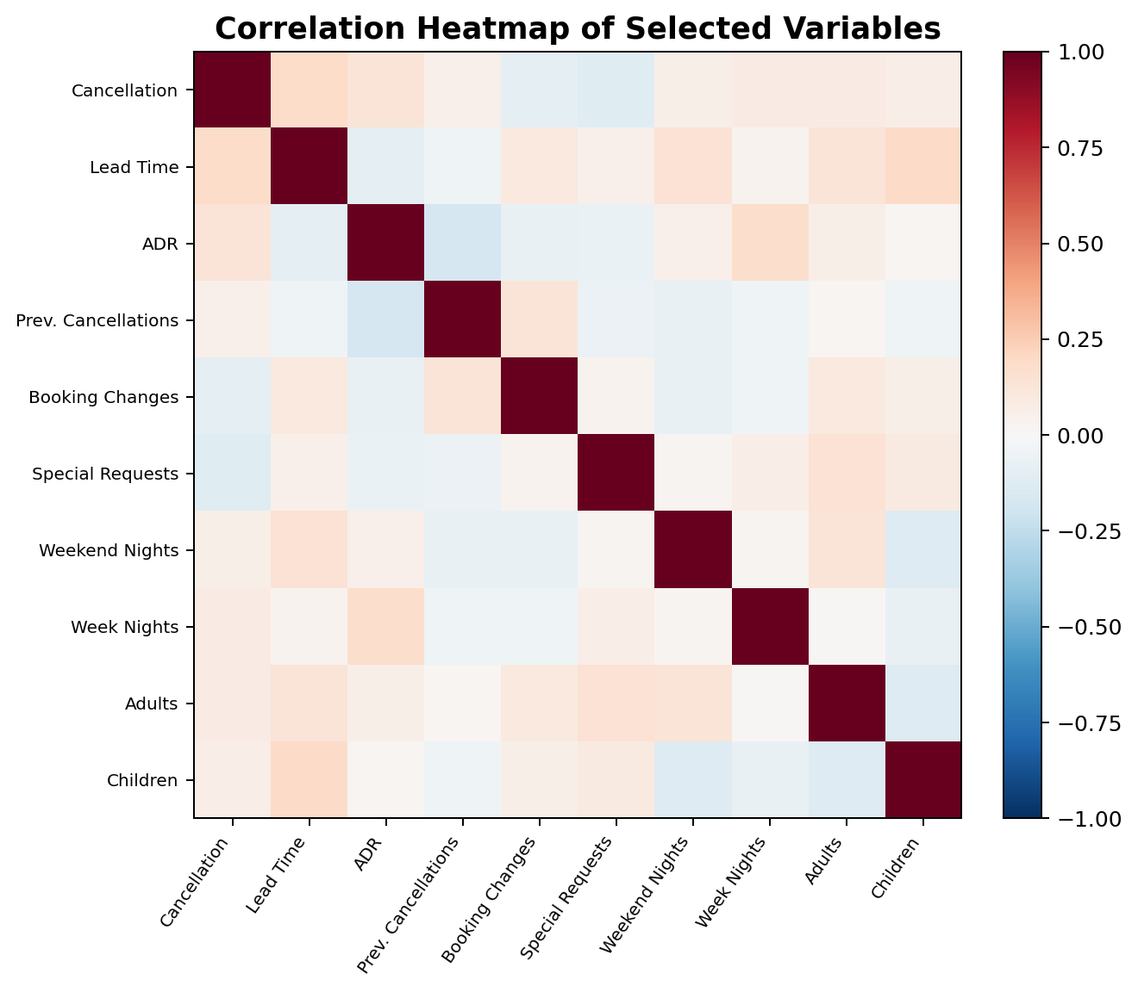

6. Train–Test Data Preparation
To prepare for predictive modelling, the cleaned dataset was divided into training and testing subsets using a fixed random seed of 123. An 80% sample was used for training and the remaining 20% for testing. This produced 69,916 training records and 17,480 testing records. The target variable is_canceled was converted to a factor before classification modelling.
Dataset | Records | Share
Training set | 69,916 | 80%
Testing set | 17,480 | 20%
Total | 87,396 | 100%
The same seed makes the split reproducible. The test set is kept separate so that the Week 4 logistic regression model can be evaluated on observations that were not used during model fitting.

7. Key Findings from Week 3
- The overall cancellation rate is 27.49%, with approximately 72.51% of bookings not cancelled.
- Cancellation behaviour varies substantially across market segments, customer types and deposit categories.
- Non Refund bookings show an exceptionally high cancellation rate and should receive attention during modelling and interpretation.
- Cancelled bookings have a much higher average lead time than non-cancelled bookings, and the difference is statistically significant.
- Cancelled bookings also have a significantly higher average ADR than non-cancelled bookings.
- The numerical correlations with cancellation are mostly weak, indicating that multiple predictors are needed rather than relying on one variable.
- The 80:20 train-test split creates a separate evaluation dataset for the predictive modelling stage.

8. Week 3 Conclusion
Week 3 established the statistical evidence and modelling-ready dataset required for the next stage. The analysis identified meaningful differences between cancelled and non-cancelled reservations and highlighted lead time, ADR, deposit type, customer type and market segment as useful explanatory variables. The prepared training and testing sets are now ready for Week 4, where logistic regression is fitted and evaluated using a confusion matrix, ROC curve and AUC.

